**BASAVARAJESWARI GROUP OF INSTITUTIONS**

### BALLARI INSTITUTE OF TECHNOLOGY & MANAGEMENT

NACC Accredited Institution*

**(Recognized by Govt. of Karnataka, approved by AICTE, New Delhi & Affiliated to Visvesvaraya Technological University, Belagavi)**

**"JnanaGangotri" Campus, No.873/2, Ballari-Hospet Road, Allipur, Ballar1-583 104 (Karnataka) (India)**

**Ph: 08392 – 237100 / 237190, Fax: 08392 – 237197**

### DEPARTMENT OF COMPUTER SCIENCE & ENGINEERING.

##### A Mini-Project Report On

**“HANGMAN GAME”**

**A report submitted in partial fulfilment of the requirements for the**

**PYTHON APPLICATION DEVELOPMENT**

**Submitted By**

**JANARDAN KULKARNI USN:3BR20CS068**

**G. SHIVARAJ USN:3BR20CS051**

##### Under the Guidance of

**Mr. Srinivasa.C.K**

**Mrs. Vijayalakshmi M**



Visvesvaraya Technological University

##### Belagavi, Karnataka 2022-2023

**BASAVARAJESWARI GROUP OF INSTITUTIONS**

**BALLARI INSTITUTE OF TECHNOLOGY & MANAGEMENT**

NACC Accredited Institution*

**(Recognized by Govt. of Karnataka, approved by AICTE, New Delhi & Affiliated to Visvesvaraya Technological University, Belagavi)**

**"JnanaGangotri" Campus, No.873/2, Ballari-Hospet Road,**

**Allipur, Ballar1-583 104 (Karnataka) (India) Ph: 08392 – 237100 / 237190, Fax: 08392 – 237197**



### DEPARTMENT OF COMPUTER SCIENCE & ENGINEERING

**CERTIFICATE**

This is to certify that the PYTHON APPLICATION DEVELOPMENT MINI-PROJECT entitled title **“HANGMAN GAME ”** has been successfully presented by JANARDAN KULKARNI **and** G.SHIVARAJbearing USN **(3BR20CS068 and 3BR20CS051)** a bona fide students of Vth semester B.E for the partial fulfilment of the requirements for the award of **Bachelor Degree in Computer Science and Engineering** of the VISVESVARAYA TECHNOLOGICAL UNIVERSITY, BELGAVI during the academic year 2022-2023.

Signature of guide Signature of HOD

**Mr. Srinivasa C. K. Dr. R.N. Kulkarni Mrs. Vijayalakshmi M**

**ABSTRACT:**

The Hangman Game In Python is written in a python programming language, In this Hangman Game Project is to implement the Hangman Game Using Python. It doesn’t require any specific modules other than random and time. Python loops and functions enough to build this game here.

A Hangman Game On Python is about guessing letters (A-Z) to form the words. If the player guesses the right letter that is within the word, the letter appears at its correct position. The user has to guess the correct word until a man is hung, then the game is over.

# INTRODUCTION

Hangman is a guessing game for two or more players. One player thinks of a word, phase or sentence and the other(s) tries to guess it by suggesting letters within a certain number of guesses. Originally a Paper and Pencil Game, there are now electronic versions.

The word to guess is represented by a row of dashes representing each letter of the word. Rules may permit or forbid proper nouns, such as names, places, brands, or slang. If the guessing player suggests a letter which occurs in the word, the other player writes it in all its correct positions. If the suggested letter does not occur in the word, the other player removes (or alternatively, adds) one element of a hanged stick-figure as a tally mark. Generally, the game ends once the word is guessed, or if the stick figure is complete — signifying that all guesses have been used.

The player guessing the word may, at any time, attempt to guess the whole word. If the word is correct, the game is over and the guesser wins. Otherwise, the other player may choose to penalize the guesser by adding an element to the diagram. On the other hand, if the guesser makes enough incorrect guesses to allow the other player to complete the diagram, the guesser loses. However, the guesser can also win by guessing all the letters that appear in the word, thereby completing the word, before the diagram is completed.

# PROBLEM STATEMENT :

To design and develop a paper and pencil guessing game for two or more players using Python.

**OBJECTIVES :**

Hangman is a guessing game for two or more players. One player thinks of a word, phase or sentence and the other(s) tries to guess it by suggesting letters within a certain number of guesses. Originally a Paper and Pencil Game, there are now electronic versions.

**HARDWARE AND SOFTWARE REQUIREMENTS:**

1. **HARDWARE REQUIREMENTS**

PROCESSOR : INTEL I5 5TH GEN AND ABOVE

RAM: 4gb

SSD/HDD : 256gb

1. **SOFTWARE REQUIREMENTS**

PYTHON VERSION : 3.4 and above.

**METHODOLOGY:**

The methods used in this Project are :

1. Main(): main function includes all declarations and implementation of the list
2. Play_loop(): this function is used to run the game again as per the users need .
3. Hangman(): this function is used to select an random word from the list and checks if the letter entered by the user is correct or not . this function also decides if the user has won the game or not as per the guess made by the user .

**RESULTS:**

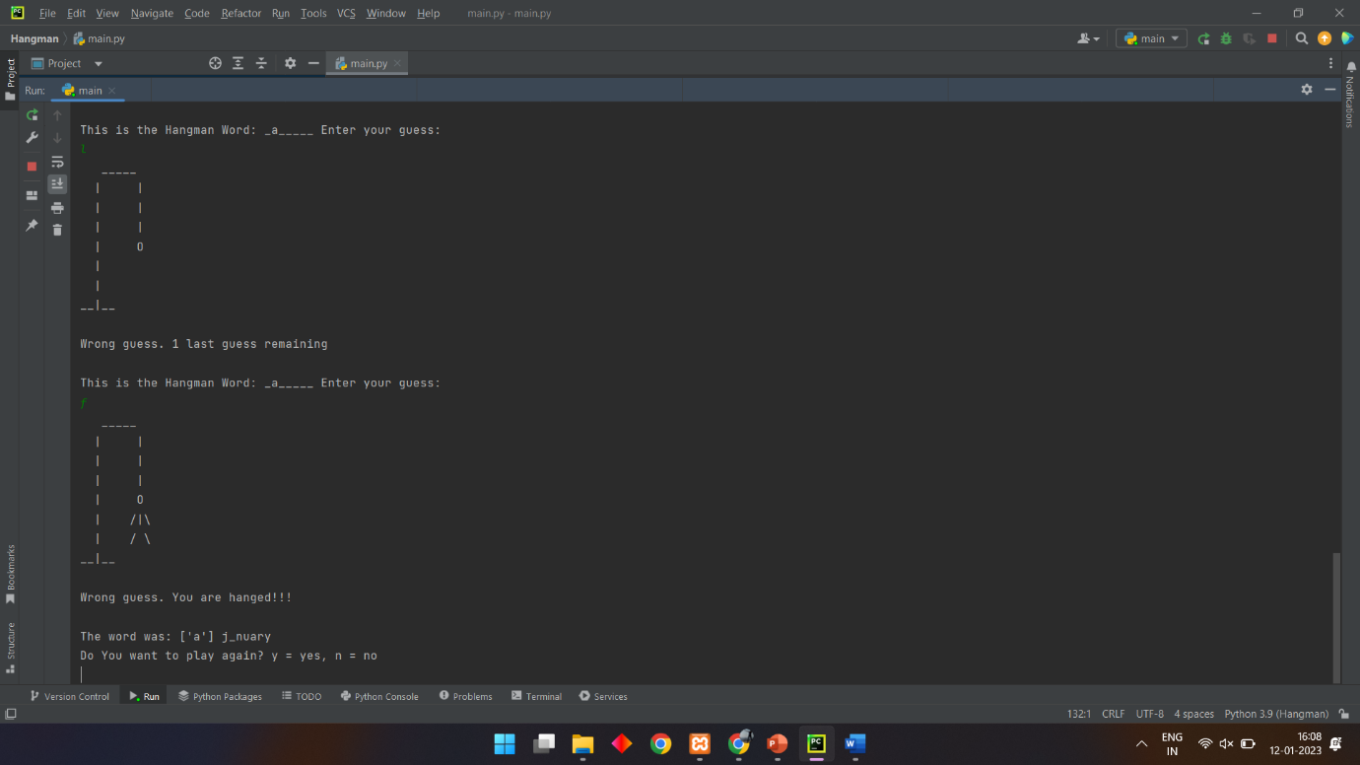

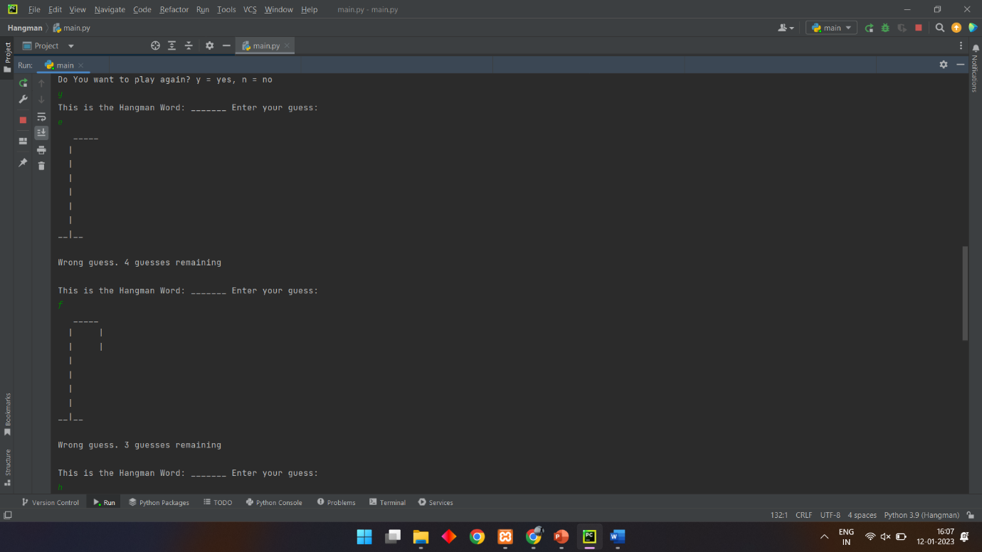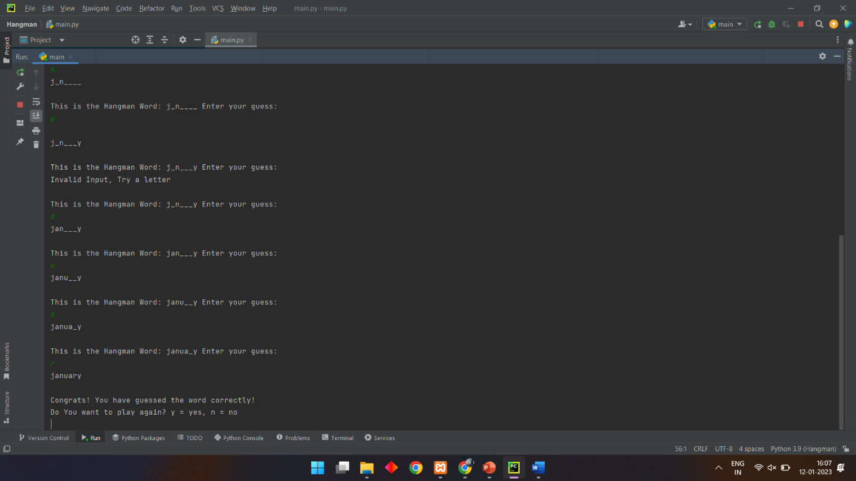

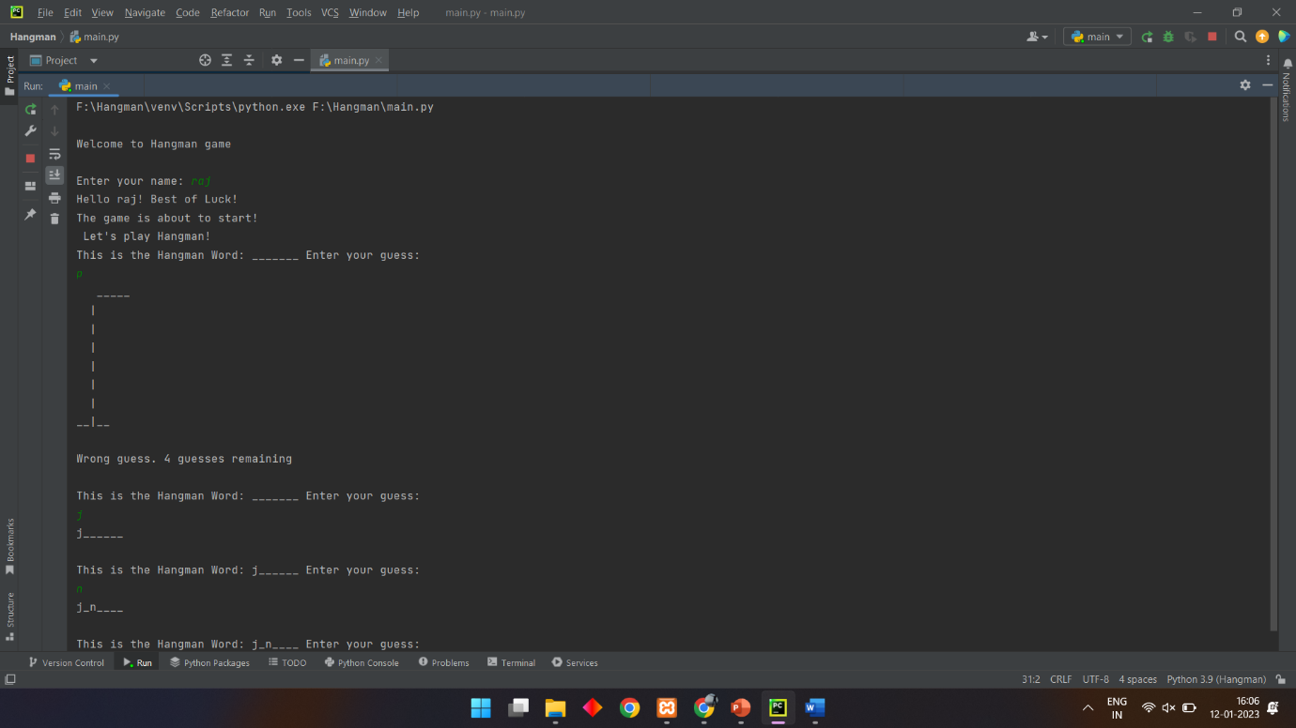

**CONCLUSION :**

The **Hangman Game In Python** project requires good knowledge of Python which includes defining functions and managing for/while loops. The functions that we use here contain arguments that are defined in a global scope which can be further used in other functions to improve game quality. It can also be used to provide different steps when required to execute upon conditions by the for and while loops.